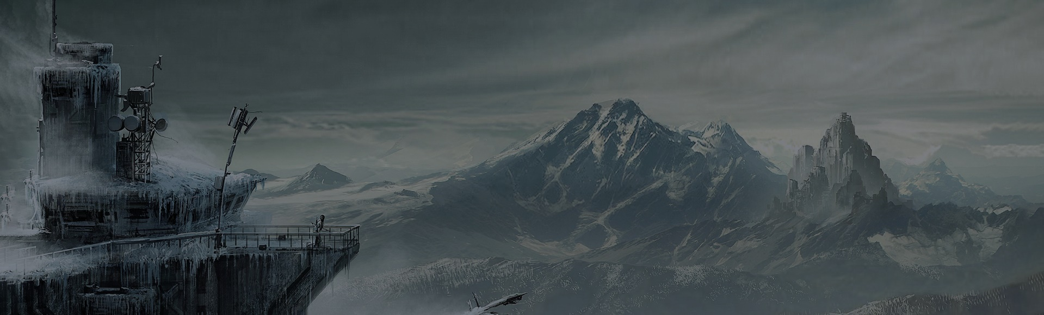
ANGSANA NIMMARN
UI Designer & Developer

www.dcrazed.com mail@dcrazed.com 091) 996-8828

EDUCATION

Fall 2002 BA, Communication & Interactive Digital Media
A school where I learnt numerous software’s including Photoshop, illustrator, inDesign and got strong background in project management and customer relations.

Fall 1998 School of Multimedia Design, Houston
Learned from the best to do web and mobile app design, brand identity, print, and social consulting for small and medium size companies.

EXPERIENCE
2010-Current Freelancer Designer I Social Blood Inc.
I was responsible for working on a range of projects, designing appealing websites and interacting on a daily basis with graphic designers.
2003-2006 Web Designer for hire I Pixel Corp.
Worked as part of a multi-disciplinary team, carrying out ad-hoc tasks as requested by the IT Manager. Had a specific brief to ensure the websites build for customer's precisely matched their requirements, developers and marketers.
1998-2002 Trainee Web Designer I Revolution Systems.
This was beginning of my career. Developed, managed, operated and promoted an Internet business. Handled customer support issues.

SKILLS PROFICIENCY

Adobe Photoshop Adobe Illustrator GitHub Atom Sketch for MAC

